AI BLOG NEST API

Final Project Documentation

Project & Team Details

Project Title: AI Blog Nest API

Team Details
Team ID: SWTID-2026-8851

Team Leader:
Keerthana CK - 24bsccs15@cttewc.edu.in

Team Members:
Kalai Selvi C- 24bsccs42@cttewc.edu.in
Kaliswari T - 24bsccs02@cttewc.edu.in
Rahima M - 24bsccs25@cttewc.edu.in

Institution:
Chevalier T. Thomas Elizabeth College for Women

---

1. Project Overview

AI Blog Nest API is a backend REST API developed for a blogging platform with authentication, blog management, and AI-assisted content features.

The application is developed using Node.js and Express.js. MongoDB is used for data storage, JWT is used for authentication, and Gemini AI is integrated to provide AI-assisted blog generation and summarization.

The project was developed and tested using Thunder Client. The major working functionalities demonstrated in the project are:

- User Registration
- User Login
- JWT Authentication
- Blog Creation
- Blog Retrieval
- AI Blog Generation
- AI Blog Summarization

---

2. Problem Statement

Traditional blogging requires users to manually create and manage content. Creating suitable blog content and preparing summaries can also require considerable time.

There is a need for a backend system that can securely manage users and blogs while providing AI-assisted features for content creation and summarization.

---

3. Proposed Solution

AI Blog Nest API provides a centralized backend system for managing users and blog content.

The system allows users to register and log in securely, create and retrieve blogs, and use AI-powered features for generating blog content and summarizing existing content.

The application follows a modular backend architecture so that different functionalities can be maintained separately.

---

4. Objectives

The main objectives of the project are:

1. To develop a RESTful backend API for a blogging application.
2. To implement secure user registration and login.
3. To use JWT authentication for protected API operations.
4. To store user and blog information using MongoDB.
5. To implement blog creation and retrieval.
6. To integrate Gemini AI for blog generation.
7. To integrate AI-based blog summarization.
8. To test the API using Thunder Client.
9. To maintain the project using Git and GitHub.

---

5. Scope of the Project

The project covers:

- User authentication
- JWT-based authorization
- Blog creation
- Blog retrieval
- MongoDB database operations
- AI-assisted blog generation
- AI-assisted blog summarization
- API testing
- Error handling
- Version control using Git and GitHub

The current project mainly focuses on backend API development.

---

6. Target Users

The system can be useful for:

- Students learning backend development
- Developers developing blogging applications
- Content creators
- Users who need AI-assisted blog content
- Users who need quick blog summaries

---

7. Technology Stack

Technology| Purpose
Node.js| Backend runtime environment
Express.js| REST API development
JavaScript| Programming language
MongoDB| Database
MongoDB Atlas| Cloud database environment
JWT| Authentication
Gemini AI| AI-assisted content generation and summarization
Thunder Client| API testing
Git| Version control
GitHub| Source code repository
Visual Studio Code| Development environment

---

8. System Modules

8.1 Authentication Module

The Authentication Module manages user registration and login.

It provides:

- User registration
- User login
- JWT token generation
- Authentication validation

---

8.2 Blog Module

The Blog Module manages blog-related operations.

It provides:

- Blog creation
- Blog retrieval
- Storage of blog information
- Association of blogs with authenticated users

---

8.3 AI Module

The AI Module integrates Gemini AI with the backend.

It provides:

- AI Blog Generation
- AI Blog Summarization

---

8.4 Database Module

The Database Module manages communication between the application and MongoDB.

It is responsible for storing and retrieving:

- User information
- Blog information

---

8.5 Middleware Module

Middleware is used for common backend operations such as:

- Authentication verification
- Error handling
- Request processing

---

8.6 Routing Module

The application separates API routes into different route groups.

The major route groups are:

- Authentication Routes
- Blog Routes
- AI Routes

---

9. Project Structure

AI Blog Nest API
│
├── node_modules/
│
├── src/
│ ├── app.js
│ ├── server.js
│ │
│ ├── config/
│ │ └── db.js
│ │
│ ├── controllers/
│ │ ├── aiController.js
│ │ ├── authController.js
│ │ └── blogController.js
│ │
│ ├── middleware/
│ │ ├── authMiddleware.js
│ │ └── errorMiddleware.js
│ │
│ ├── models/
│ │ ├── Blog.js
│ │ └── User.js
│ │
│ ├── routes/
│ │ ├── aiRoutes.js
│ │ ├── authRoutes.js
│ │ └── blogRoutes.js
│ │
│ └── services/
│ └── geminiService.js
│
├── .env
├── .gitignore
├── package.json
├── package-lock.json
├── README.md
├── thunder-client-ai-blognest-api.postman_collection.json
└── thunder-client-env.json

---

10. Functional Requirements

10.1 User Registration

The system should allow a new user to create an account.

10.2 User Login

The system should authenticate registered users and provide a JWT token.

10.3 JWT Authentication

Protected API operations should require valid authentication.

10.4 Blog Creation

Authenticated users should be able to create blog content.

10.5 Blog Retrieval

Users should be able to retrieve stored blog information through the API.

10.6 AI Blog Generation

The system should generate blog content using Gemini AI.

10.7 AI Blog Summarization

The system should generate a concise summary of blog content using Gemini AI.

10.8 Database Operations

The application should store and retrieve user and blog information from MongoDB.

10.9 Error Handling

The application should handle invalid requests and service errors appropriately.

---

11. Non-Functional Requirements

Performance

The API should respond within a reasonable time under normal usage.

Security

Authentication information and sensitive environment variables should be protected.

Reliability

The system should handle database and API errors appropriately.

Maintainability

The backend is divided into routes, controllers, services, models, and middleware.

Scalability

The modular architecture allows additional features to be added later.

Usability

The API endpoints can be tested easily using Thunder Client.

---

12. Database Design

MongoDB is used as the database for the project.

The application contains models for:

User

The User model stores information required for user authentication and identification.

Blog

The Blog model stores blog-related information and associates the blog with the authenticated user.

MongoDB Atlas can be used as the cloud database environment.

The database connection details are stored through environment variables.

---

13. Authentication and Security

JWT-based authentication is implemented in the application.

The authentication process works as follows:

1. User registers an account.
2. User logs in using valid credentials.
3. The server authenticates the user.
4. A JWT token is generated.
5. The token is used for protected API requests.
6. Authentication middleware verifies the token.

Sensitive values such as database credentials and API keys are stored in the ".env" file.

The ".env" file is excluded from Git tracking using ".gitignore".

---

14. Blog Management

The Blog Module provides the core blogging functionality.

Authenticated users can create blogs through the API.

The created blog information is stored in MongoDB.

The Blog Retrieval functionality allows stored blog information to be fetched through the API.

The module is organized using:

- Blog Routes
- Blog Controller
- Blog Model
- Authentication Middleware

---

15. AI Integration

Gemini AI is integrated into the backend through a dedicated AI service.

15.1 AI Blog Generation

The user provides the required input through the API.

The backend sends the request to the Gemini AI service.

The generated blog content is returned as the API response.

15.2 AI Blog Summarization

Existing blog content can be sent to the AI service.

Gemini AI processes the content and generates a shorter summary.

The generated summary is returned through the API.

The AI integration is separated into a service layer to make the system easier to maintain.

---

16. API Testing

Thunder Client was used to test the API endpoints during development.

The following major functionalities were tested:

Feature| Expected Result| Status
MongoDB Connection| Database connects successfully| Passed
User Registration| User is registered successfully| Passed
User Login| User receives authentication response| Passed
JWT Authentication| Protected request is authenticated| Passed
Blog Creation| Blog is created successfully| Passed
Blog Retrieval| Blog information is retrieved| Passed
AI Blog Generation| AI-generated blog is returned| Passed
AI Blog Summarization| AI-generated summary is returned| Passed

---

17. Installation and Setup

Step 1: Install Node.js

Install Node.js on the system.

Step 2: Open the Project

Open the project folder using Visual Studio Code.

Step 3: Install Dependencies

Run:

npm install

Step 4: Configure Environment Variables

Create a ".env" file and provide the required:

- MongoDB connection string
- JWT configuration
- Gemini AI API configuration

Step 5: Start the Server

Run:

npm run dev

Step 6: Test the API

Open Thunder Client and send requests to the required API endpoints.

---

18. Version Control and GitHub

Git was used for version control throughout the project.

The project source code was pushed to GitHub.

GitHub Repository:

https://github.com/KeerthanaCK379/AI_Blog_Nest_API

The ".env" file and "node_modules" folder are excluded from the repository using ".gitignore".

Project documentation and phase-wise submission files are maintained in separate folders inside the repository.

---

19. Project Benefits

The project provides the following benefits:

- Provides a reusable blogging backend.
- Demonstrates REST API development.
- Implements secure authentication.
- Uses MongoDB for persistent data storage.
- Integrates AI into a practical application.
- Supports AI-assisted blog creation.
- Supports AI-assisted summarization.
- Demonstrates API testing using Thunder Client.
- Demonstrates Git and GitHub workflow.
- Provides a modular and maintainable backend structure.

---

20. Limitations

The current project has the following limitations:

1. The project mainly focuses on backend API functionality.
2. A complete frontend user interface is not included in the current scope.
3. AI functionality depends on the availability and configuration of the Gemini AI service.
4. Advanced production monitoring and large-scale performance testing are outside the current scope.

---

21. Future Enhancements

The following features can be added in future versions:

- Dedicated frontend application
- Blog editing
- Blog deletion
- Categories and tags
- Search functionality
- Pagination
- User profile management
- Improved AI prompting
- Different AI writing styles
- Cloud deployment
- Automated unit testing
- Automated integration testing
- Advanced monitoring and logging

---

22. Project Outcome and Screenshots

The AI Blog Nest API was developed and tested using Thunder Client.

The following screenshots demonstrate the major working functionalities of the project.

22.1 User Registration

Figure 1: Successful User Registration

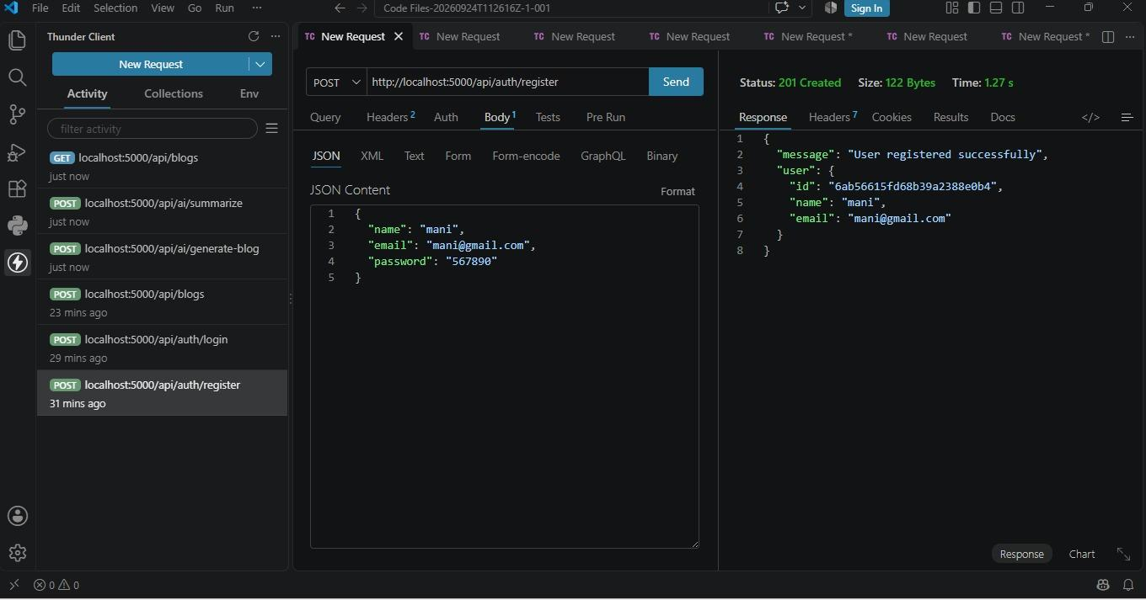

---

22.2 User Login

Figure 2: Successful User Login

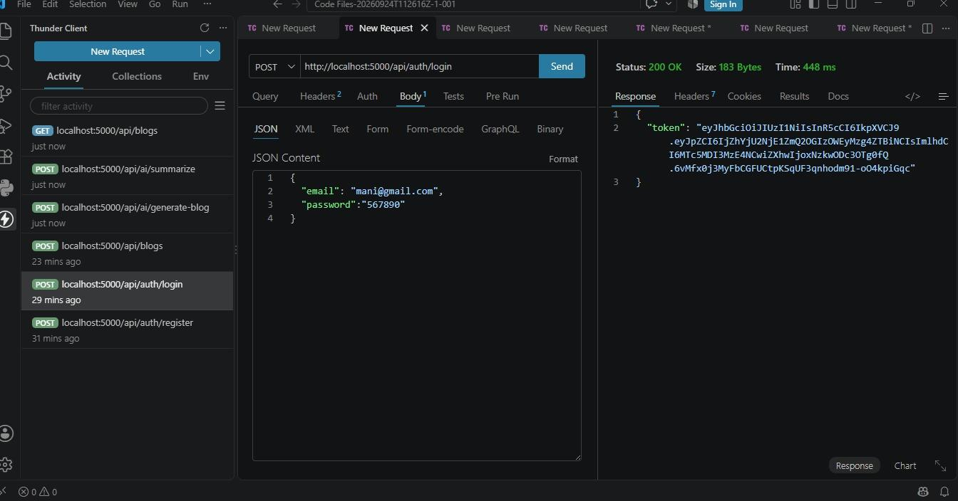

---

22.3 Blog Creation

Figure 3: Successful Blog Creation

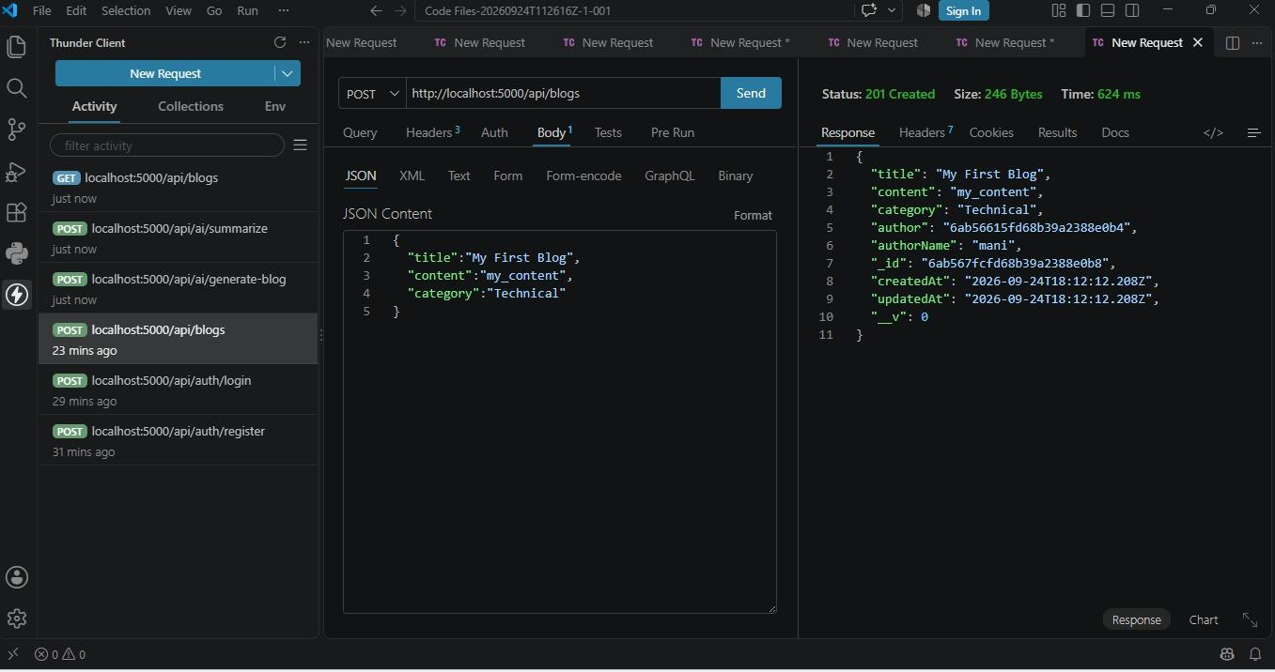

---

22.4 Fetch Blog

Figure 4: Successful Blog Retrieval

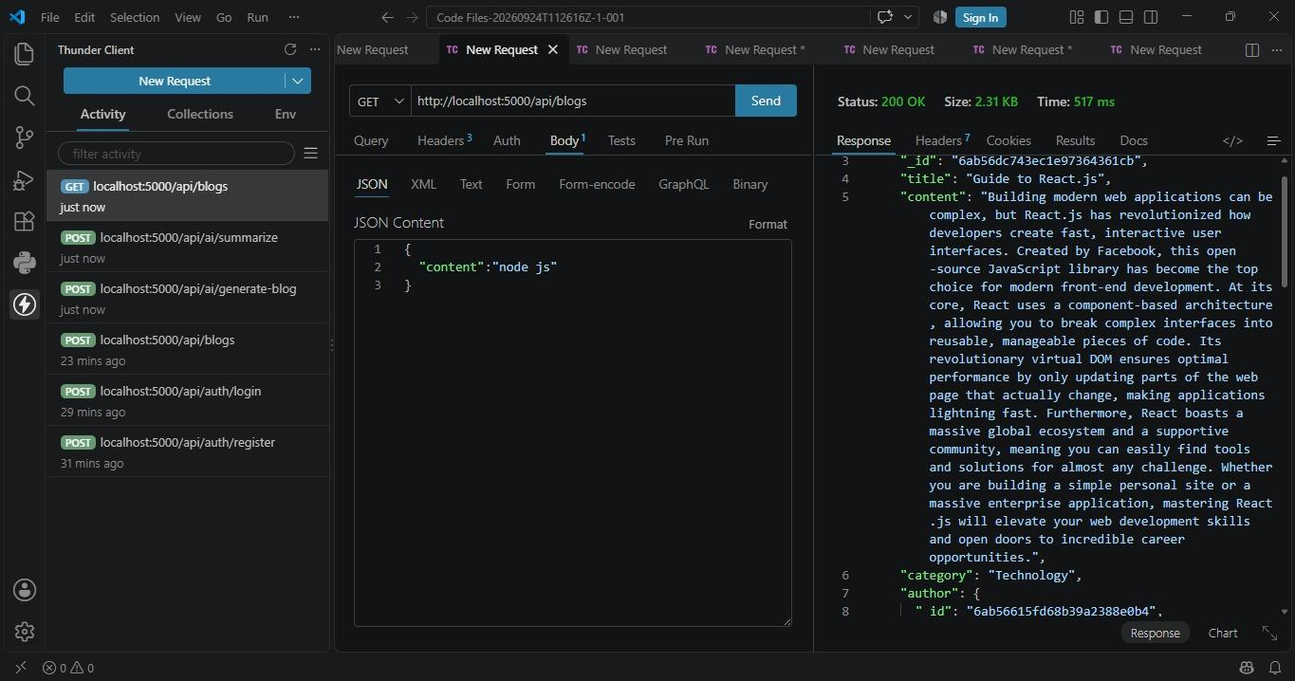

---

22.5 AI Blog Generation

Figure 5: AI-Generated Blog Output

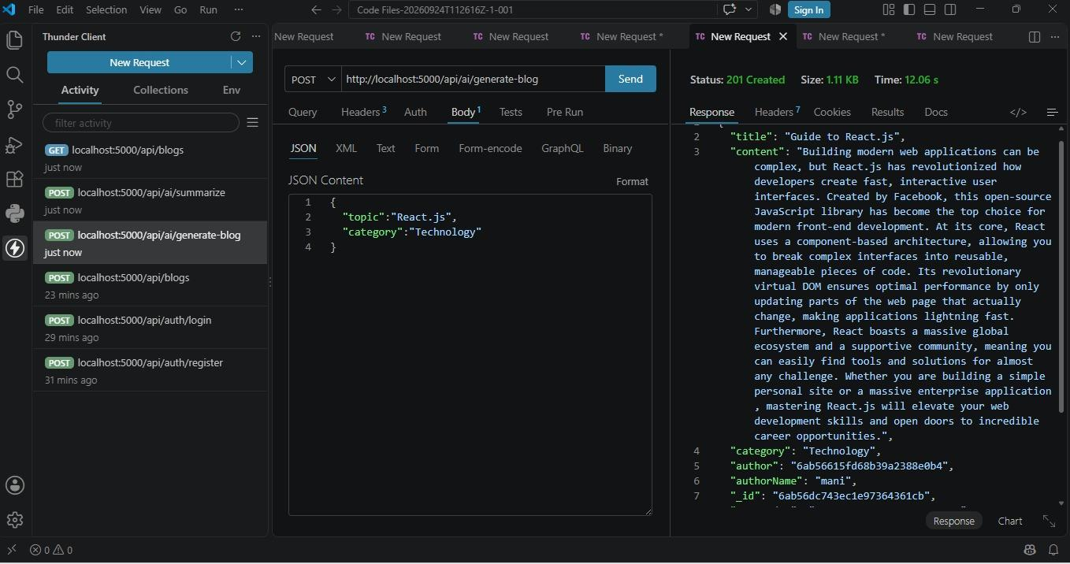

---

22.6 AI Blog Summarization

Figure 6: AI Blog Summarization Output

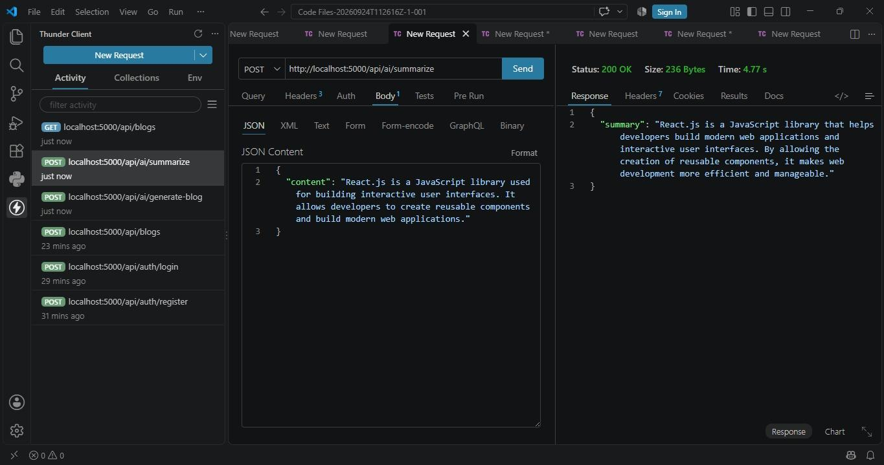

---

23. Project Documentation Outcome

The project documentation provides a complete record of the development process of AI Blog Nest API.

It covers:

- Project idea
- Problem statement
- Objectives
- Requirements
- Technology stack
- System modules
- Project structure
- Database design
- Authentication
- Blog management
- AI integration
- API testing
- Installation
- Version control
- Benefits
- Limitations
- Future enhancements
- Project screenshots

The documentation can be used as the final technical record for the project submission.

---

24. Conclusion

AI Blog Nest API demonstrates the development of a backend blogging system using Node.js, Express.js, MongoDB, JWT authentication, and Gemini AI.

The project successfully demonstrates user registration, user login, authenticated blog creation, blog retrieval, AI-assisted blog generation, and AI-assisted blog summarization.

The modular backend architecture makes the application easier to understand, maintain, and extend. The project also demonstrates practical API testing using Thunder Client and version control using Git and GitHub.

The system provides a strong foundation for future enhancements such as frontend development, advanced blog management, cloud deployment, and additional AI-powered features.

